**ASSIGNMENT 8 – React Application Testing and Deployment**

**Code :**

<https://github.com/hemapunniakotti/ReactProjects/tree/main/Assignment8_ReactTestDocker>

**Output :**

1. $ npm install -save-dev jest
2. Created tests for Components and Reducers which passed.
3. Run the test using npm run test.

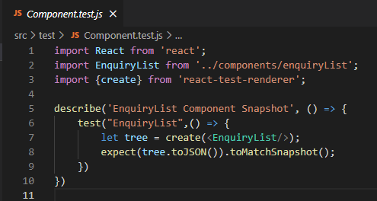

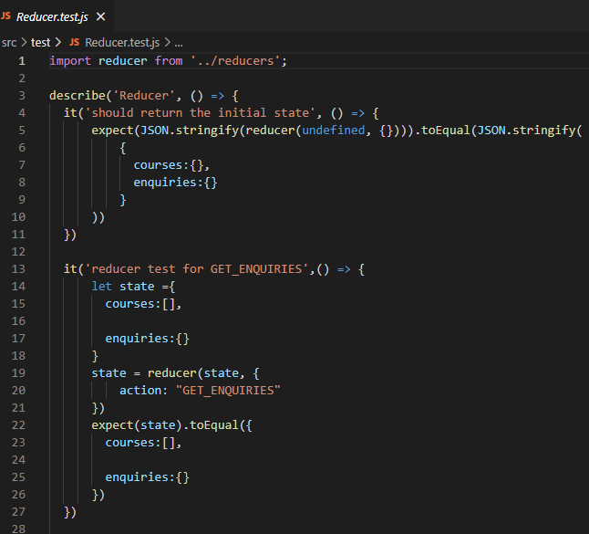

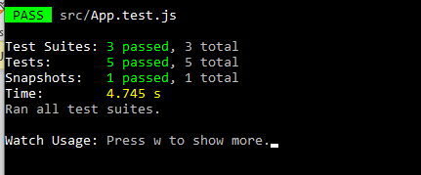

TO BUILD AND PUBLISH IN DOCKER :

1. With the “npm run build” I build to production

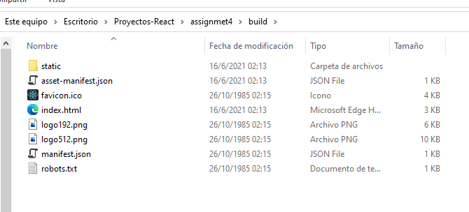

1. I create a dockerFile in order to create a docker image.

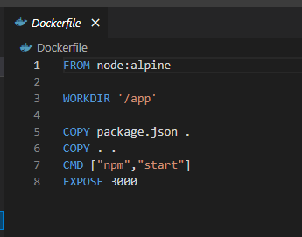

1. Then I downloaded Docker and when to my project location on CMD and the I write the next command: docker build -t assignment8 .
2. After the image was created I had to add a tag with the command: docker tag assignment8 pednev7/assignment8
3. And I had to push the image on dockerhub with the command: docker push pednev7/assignment8

